|  |  |
| --- | --- |
|  | Self-Biased Sub-1V Bandgap Reference Circuit |
|  |  |
|  | Bilal Ramadan  Supervisor: Dr. Hesham Omran |

Table of Contents

Part 1: Design Required Specs 3

Part 2: BGR Core Circuit 3

1. OP simulation 4

2. DC temperature sweep simulation 5

Part 3: Error Amplifier 6

1. OP simulation 7

2. DC temperature sweep simulation 8

3. Stability analysis 8

Part 4: Startup Circuit 9

1. OP simulation 10

2. Transient analysis supply ramp 11

Part 5: Achieved Specs 11

Tables

Table 1: Required specs 3

Table 2: Achieved specs 11

Table of Figures

Figure 1: schematic 3

Figure 2: Error amplifier behavioral model 4

Figure 3: schematic with DC OP and node voltages annotated 4

Figure 4: Vref vs temperature with 0.8 mV change 5

Figure 5: Vref across corners with 6 mV change 5

Figure 6: schematic 6

Figure 7: Error amplifier schematic 6

Figure 8: schematic with DC OP and node voltages annotated 7

Figure 9: Error amplifier schematic with DC OP and node voltages annotated 7

Figure 10: Vref across corners 8

Figure 11: Gain crossover frequency 8

Figure 12: schematic 9

Figure 13: Error amplifier schematic 9

Figure 14: schematic with DC OP and node voltages annotated 10

Figure 15: Error amplifier schematic with DC OP and node voltages annotated 10

Figure 16: Transient Vref across corners at room temperature 11

# Design Required Specs

|  |  |
| --- | --- |
| Technology | $$65 nm CMOS$$ |
| Supply Voltage | $$2 V$$ |
| Change versus Temperature | $$<1 mV$$ |
| Change across Corners | $$<10 mV$$ |
| Current consumption | $$<10 μA$$ |
| Phase margin |  |

Table : Required specs

The Design will be on three phases as follows:

# BGR Core Circuit

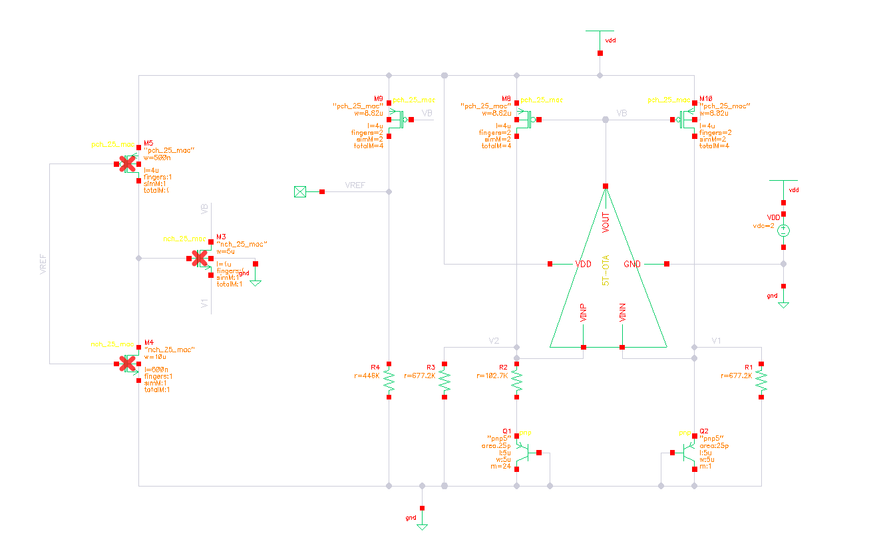

Figure : schematic

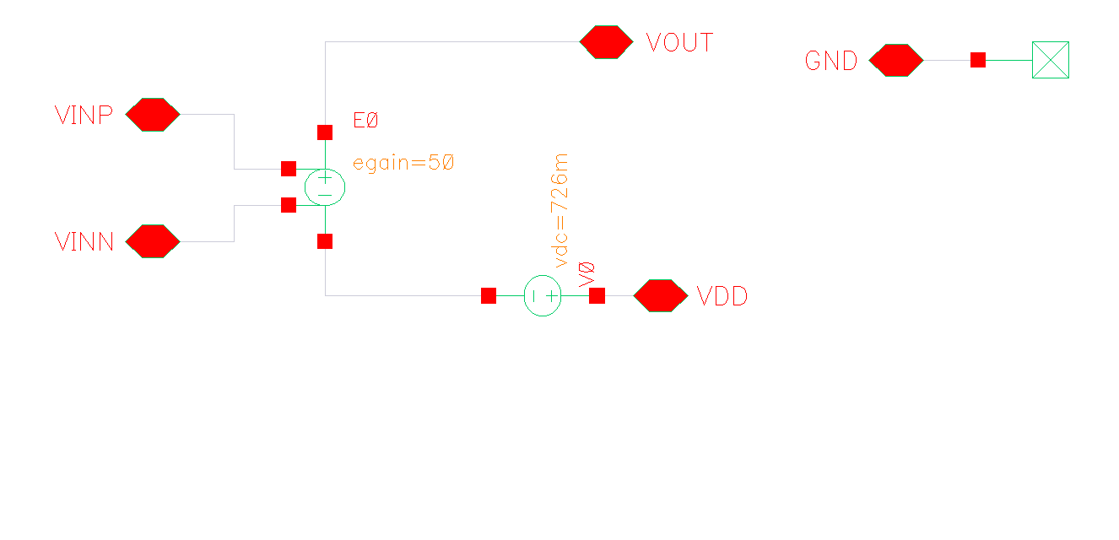

Figure : Error amplifier behavioral model

## OP simulation

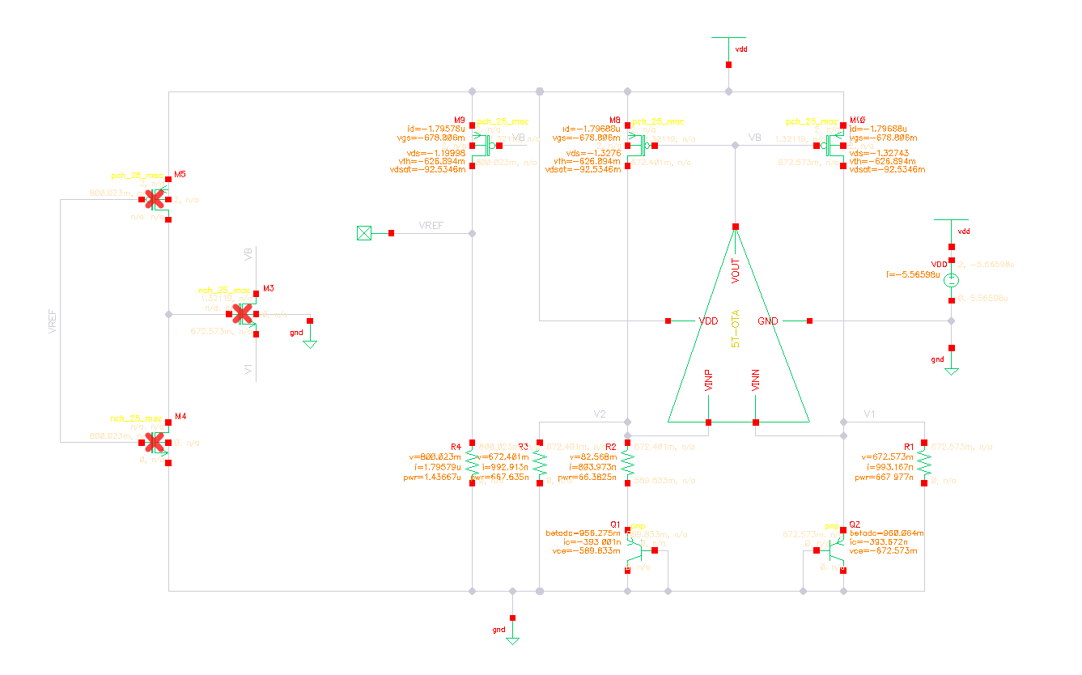

Figure : schematic with DC OP and node voltages annotated

## DC temperature sweep simulation

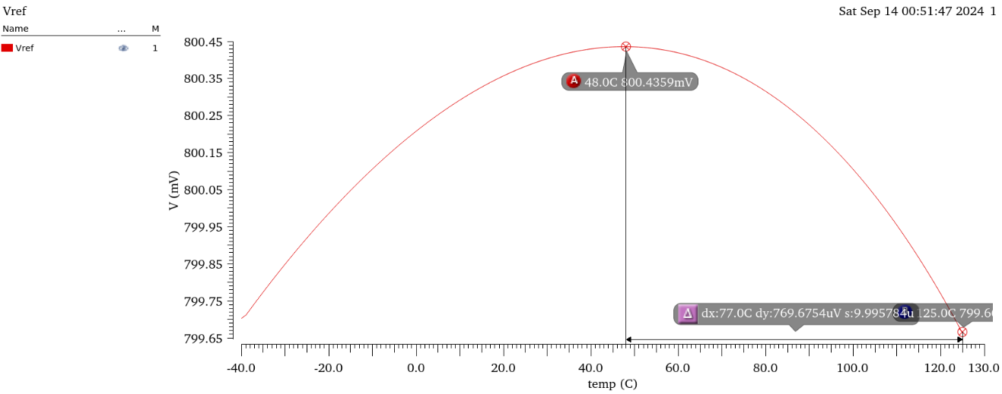

Figure : Vref vs temperature with 0.8 mV change

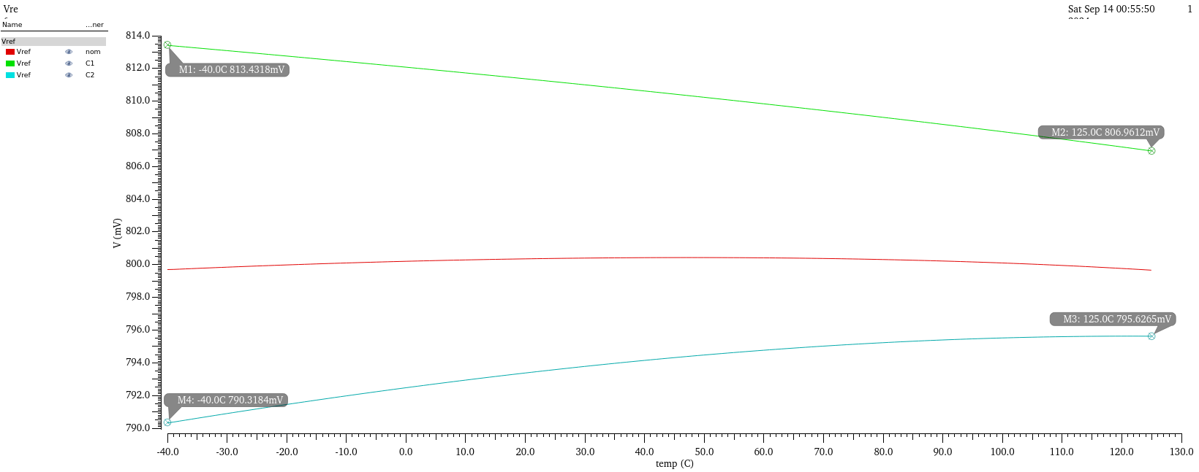

Figure : Vref across corners with 10 mV change

# Error Amplifier



Figure : schematic

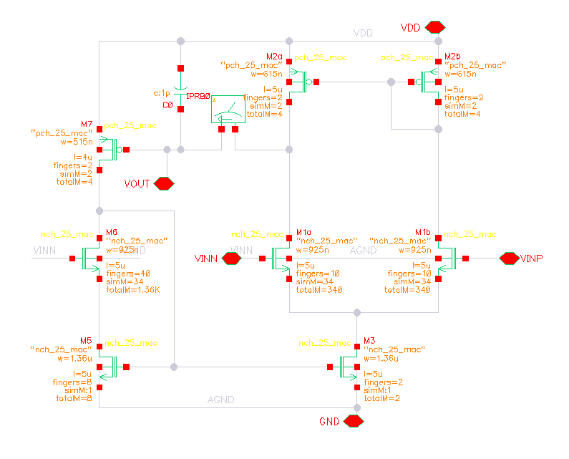

Figure : Error amplifier schematic

## OP simulation

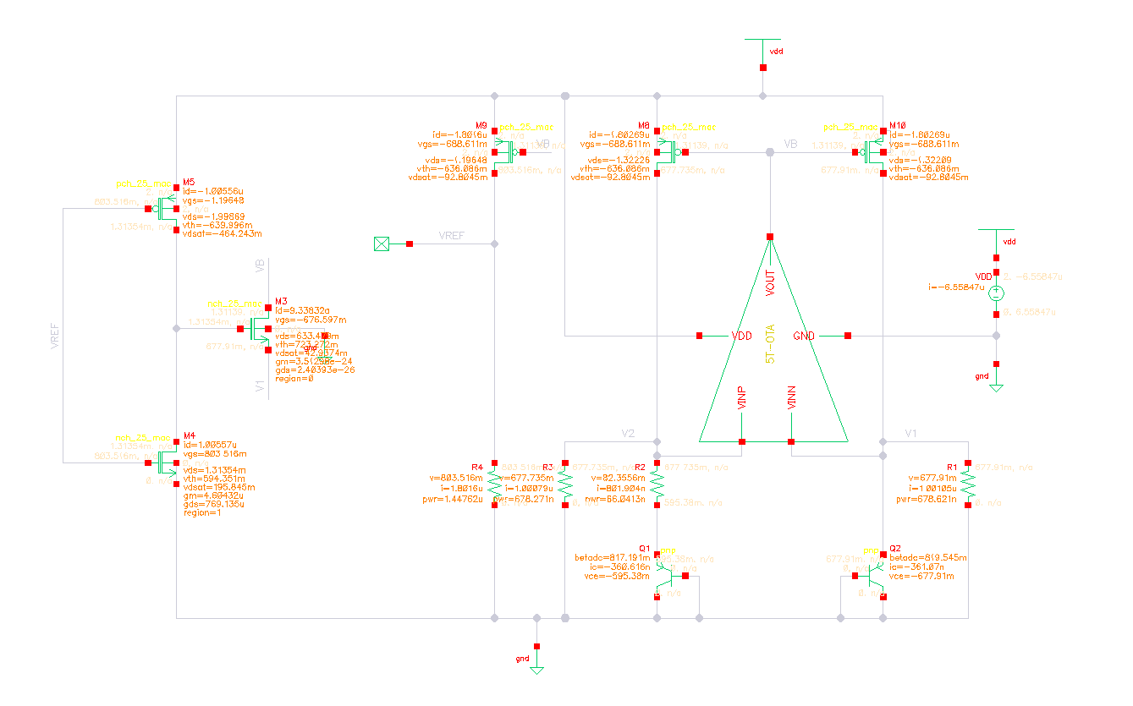

Figure : schematic with DC OP and node voltages annotated

Total power consumption $=6.6 μΑ$

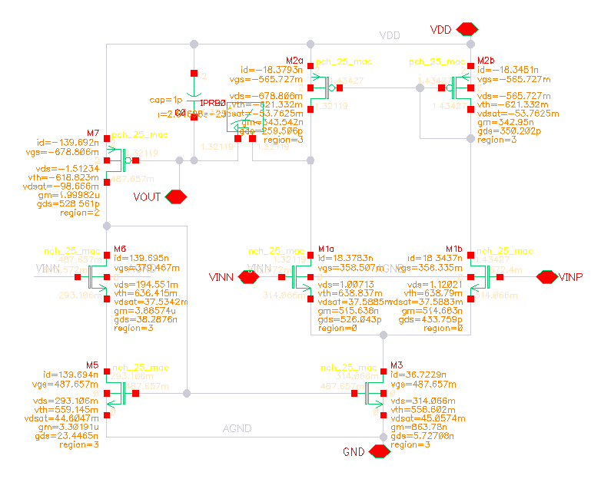

Figure : Error amplifier schematic with DC OP and node voltages annotated

## DC temperature sweep simulation

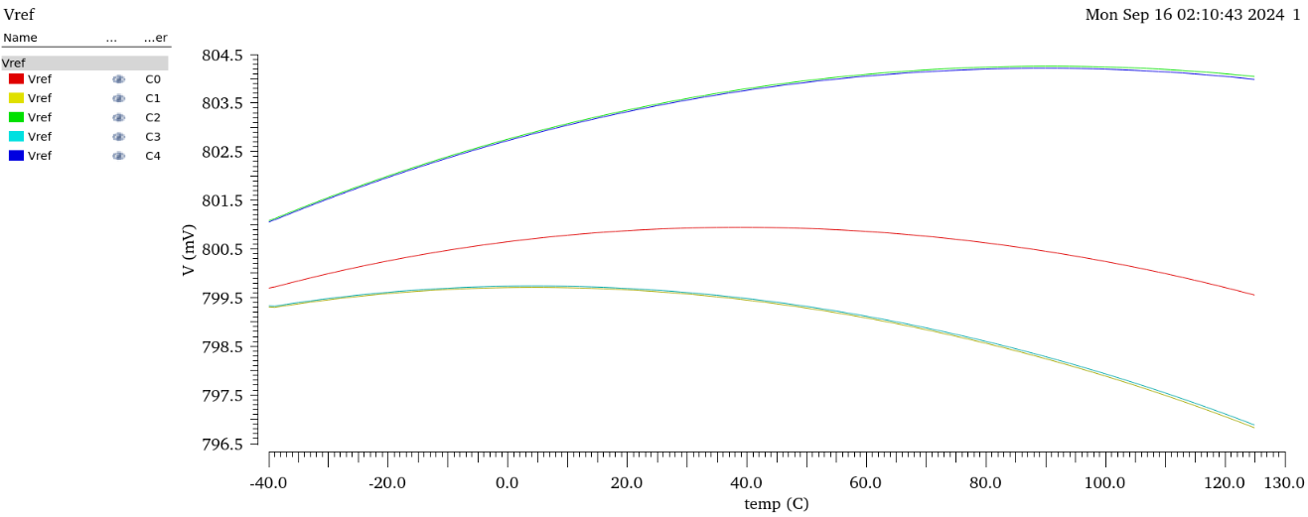

Figure : Vref across corners

## Stability analysis

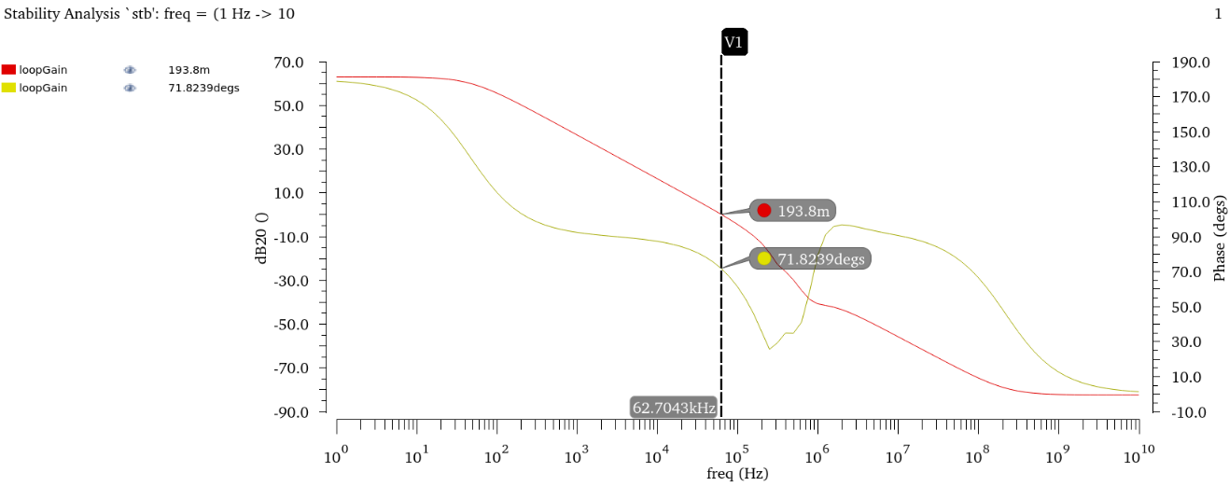

Figure : Gain crossover frequency

$$PM={72}^{o}$$

# Startup Circuit

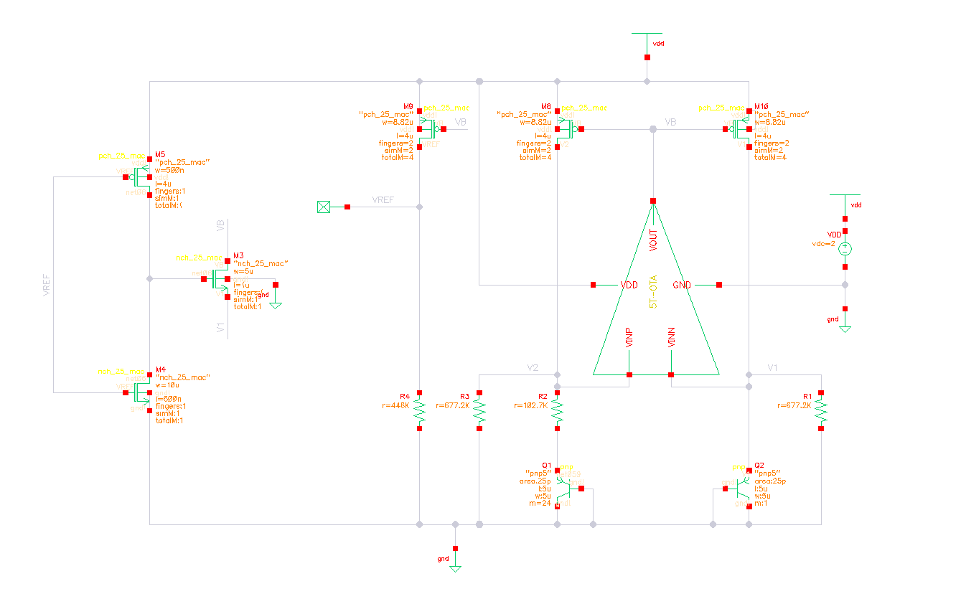

Figure : schematic



Figure : Error amplifier schematic

## OP simulation



Figure : schematic with DC OP and node voltages annotated



Figure : Error amplifier schematic with DC OP and node voltages annotated

## Transient analysis supply ramp

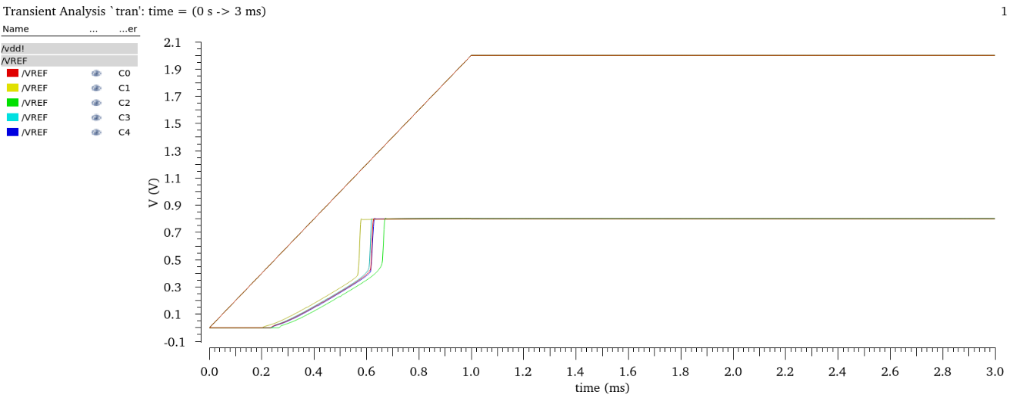

Figure : Transient Vref across corners at room temperature

# Achieved Specs

|  |  |  |
| --- | --- | --- |
| Spec | Required | Achieved |
| Supply Voltage | $$2 V$$ | $$2 V$$ |
| Change versus Temperature | $$<1 mV$$ | $$0.8 mV$$ |
| Change across Corners | $$<10 mV$$ | $$10 mV$$ |
| Current consumption | $$<10 μA$$ | $$6.6 μA$$ |
| Phase margin |  |  |

Table : Achieved specs